
SCHOOL OF COMPUTING AND ENGINEERING SCIENCES (SCES)
BACHELOR OF SCIENCE IN ELECTRICAL AND ELECTRONIC ENGINEERING
Introduction to Vision and Robotics
Peter Corke’s Chapter 2 Lab
By
Edward Aribu – 142092

%% Robotics, Vision & Control 3e: for MATLAB
%% Chapter 2: Representing position & orientation
%
%%
% Copyright 2022-2023 Peter Corke, Witold Jachimczyk, Remo Pillat

close all % close all existing figures
%% 2.2 Working in Two Dimensions (2D)
% 2.2.1 Orientation in Two Dimensions
% 2.2.1.1 2D Rotation Matrix

R = rotm2d(0.3)
plottform2d(R);
det(R)
det(R*R)
syms theta real
R = rotm2d(theta)
simplify(R * R)
det(R)
simplify(ans)

output:

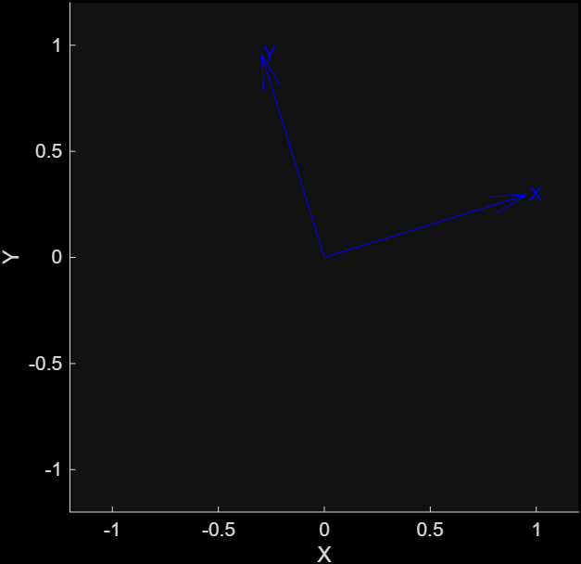
>> peter_corkes_chapter2_code
R =
0.9553 -0.2955
0.2955 0.9553
ans =
1.0000
ans =
1.0000
R =
[cos(theta), -sin(theta)]
[sin(theta), cos(theta)]
ans =
[cos(2*theta), -sin(2*theta)]
[sin(2*theta), cos(2*theta)]
ans =
cos(theta)^2 + sin(theta)^2
ans =
1
>>
%% Robotics, Vision & Control 3e: for MATLAB
%% Chapter 2: Representing position & orientation
%
%%
% Copyright 2022-2023 Peter Corke, Witold Jachimczyk, Remo Pillat

close all % close all existing figures
% 2.2.1.2 Matrix Exponential for Rotation

R = rotm2d(0.3);
L = logm(R)
S = skew2vec(L)
X = vec2skew(2)
skew2vec(X)
expm(L)
expm(vec2skew(S))

output:
>> peter_corkes_chapter2_code
L =
0 -0.3000
0.3000 0
S =
0.3000
X =
0 -2
2 0
ans =
2
ans =
0.9553 -0.2955
0.2955 0.9553
ans =
0.9553 -0.2955
0.2955 0.9553
>>

%% Robotics, Vision & Control 3e: for MATLAB
%% Chapter 2: Representing position & orientation
%

% 2.2.2 Pose in Two Dimensions
% 2.2.2.1 2D Homogeneous Transformation Matrix

rotm2d(0.3)
tformr2d(0.3)
TA = trvec2tform([1 2])*tformr2d(deg2rad(30))
clf; axis([0 5 0 5]); hold on % new plot with both axes from 0 to 5
plottform2d(TA,frame="A",color="b");
T0 = trvec2tform([0 0]);
plottform2d(T0, frame="0",color="k"); % reference frame
TB = trvec2tform([2 1])
plottform2d(TB,frame="B",color="r");
TAB = TA*TB
plottform2d(TAB,frame="AB",color="g");
TBA = TB*TA;
plottform2d(TBA,frame="BA",color="c");
P = [3;2]; % column vector
plotpoint(P',"ko",label="P");
inv(TA)*[P;1]
h2e(ans')
homtrans(inv(TA),P')

output:
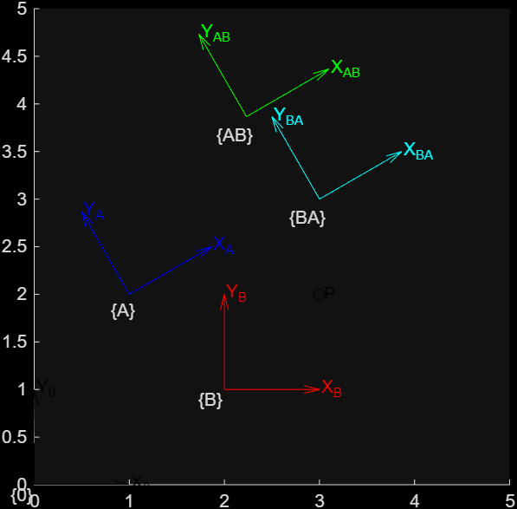
>> peter_corkes_chapter2_code
ans =
0.9553 -0.2955
0.2955 0.9553
ans =
0.9553 -0.2955 0
0.2955 0.9553 0
0 0 1.0000
TA =
0.8660 -0.5000 1.0000
0.5000 0.8660 2.0000
0 0 1.0000
TB =
1 0 2
0 1 1
0 0 1
TAB =
0.8660 -0.5000 2.2321
0.5000 0.8660 3.8660
0 0 1.0000
ans =
1.7321
-1.0000
1.0000
ans =
1.7321 -1.0000
ans =
1.7321 -1.0000

>>
%% Robotics, Vision & Control 3e: for MATLAB
%% Chapter 2: Representing position & orientation
%
% 2.2.2.2 Rotating a Coordinate Frame

clf; axis([-5 4 -1 5]);
T0 = trvec2tform([0 0]);
plottform2d(T0,frame="0",color="k"); % reference frame
TX = trvec2tform([2 3]);
plottform2d(TX,frame="X",color="b"); % frame {X}
TR = tformr2d(2);
plottform2d(TR*TX,framelabel="RX",color="g");
plottform2d(TX*TR,framelabel="XR",color="g");
C = [3 2];
plotpoint(C,"ko",label="C");
TC = trvec2tform(C)*TR*trvec2tform(-C)
plottform2d(TC*TX,framelabel="XC",color="r");

output:
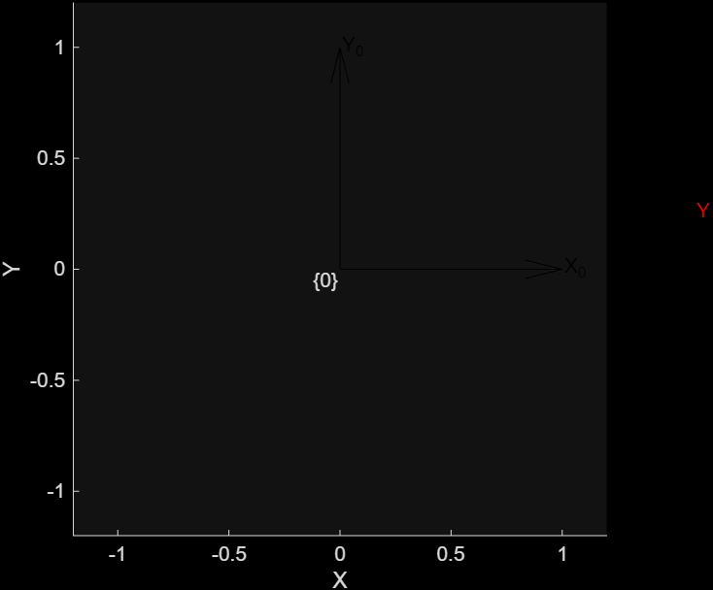

>> peter_corkes_chapter2_code
TC =
-0.4161 -0.9093 6.0670
0.9093 -0.4161 0.1044
0 0 1.0000

>>
%% Robotics, Vision & Control 3e: for MATLAB
%% Chapter 2: Representing position & orientation
%
% 2.2.2.3 Matrix Exponential for Pose

L = logm(TC)
S = skewa2vec(L)
expm(vec2skewa(S))
X = vec2skewa([1 2 3])
skewa2vec(X)

output:
>> peter_corkes_chapter2_code
L =
0 -2.0000 4.0000
2.0000 0 -6.0000
0 0 0
S =
2.0000 4.0000 -6.0000
ans =
-0.4161 -0.9093 6.0670
0.9093 -0.4161 0.1044
0 0 1.0000
X =
0 -1 2
1 0 3
0 0 0
ans =
1 2 3

>>
%% Robotics, Vision & Control 3e: for MATLAB
%% Chapter 2: Representing position & orientation
%% 2.2.2.4 2D Twists

S = Twist2d.UnitRevolute(C)
expm(vec2skewa(2*S.compact))
S.tform(2)
S.pole
S = Twist2d.UnitPrismatic([0 1])
S.tform(2)
T = trvec2tform([3 4])*tformr2d(0.5)
S = Twist2d(T)
S.w
S.pole
S.tform()

Output:
>> peter_corkes_chapter2_code
S =
( 1; 2 -3 )
ans =
-0.4161 -0.9093 6.0670
0.9093 -0.4161 0.1044
0 0 1.0000
ans =
-0.4161 -0.9093 6.0670
0.9093 -0.4161 0.1044
0 0 1.0000
ans =
3 2
S =
( 0; 0 1 )
ans =
1 0 0
0 1 2
0 0 1
T =
0.8776 -0.4794 3.0000
0.4794 0.8776 4.0000
0 0 1.0000
S =
( 0.5; 3.9372 3.1663 )
ans =
0.5000
ans =
-3.1663 3.9372
ans =
0.8776 -0.4794 3.0000
0.4794 0.8776 4.0000
0 0 1.0000

>>
%% Robotics, Vision & Control 3e: for MATLAB
%% Chapter 2: Representing position & orientation
% 2.3 Working in Three Dimensions (3D)
% 2.3.1 Orientation in Three Dimensions
% 2.3.1.1 3D Rotation Matrix

R = rotmx(pi/2)
clf; plottform(R);
clf; animtform(R)
clf; plottform(R,anaglyph="rc", axis=[-2 2 -2 2 -2 2])
clf; animtform(R,anaglyph="rc", axis=[-2 2 -2 2 -2 2]);
R = rotmx(pi/2)*rotmy(pi/2)
clf; plottform(R)
rotmy(pi/2)*rotmx(pi/2)

output:
>> peter_corkes_chapter2_code
R =
1 0 0
0 0 -1
0 1 0
R =
0 0 1
1 0 0
0 1 0
ans =
0 1 0
0 0 -1
-1 0 0

>>
%% Robotics, Vision & Control 3e: for MATLAB
%% Chapter 2: Representing position & orientation
% 2.3.1.2 Three-Angle Representations

R = rotmz(0.1)*rotmy(-0.2)*rotmz(0.3)
R = eul2rotm([0.1 -0.2 0.3],"ZYZ")
gamma = rotm2eul(R,"ZYZ")
R = eul2rotm([0.1 0.2 0.3],"ZYZ")
gamma = rotm2eul(R,"ZYZ")
eul2rotm(gamma,"ZYZ")
R = eul2rotm([0.1 0 0.3],"ZYZ")
rotm2eul(R,"ZYZ")
R = eul2rotm([0.3 0.2 0.1],"ZYX")
gamma = rotm2eul(R,"ZYX")
R = eul2rotm([0.3 0.2 0.1],"XYZ")
gamma = rotm2eul(R,"XYZ")
tripleangleApp

output:
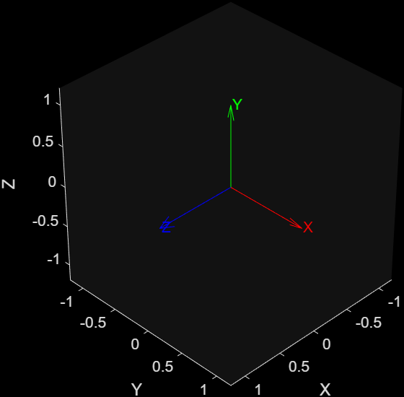

%% Robotics, Vision & Control 3e: for MATLAB
%% Chapter 2: Representing position & orientation
% 2.3.1.2 Three-Angle Representations (version 2)

R = rotmz(0.1)*rotmy(-0.2)*rotmz(0.3)
R = eul2rotm([0.1 -0.2 0.3],"ZYZ")
gamma = rotm2eul(R,"ZYZ")
R = eul2rotm([0.1 0.2 0.3],"ZYZ")
gamma = rotm2eul(R,"ZYZ")
eul2rotm(gamma,"ZYZ")
R = eul2rotm([0.1 0 0.3],"ZYZ")
rotm2eul(R,"ZYZ")
R = eul2rotm([0.3 0.2 0.1],"ZYX")
gamma = rotm2eul(R,"ZYX")
R = eul2rotm([0.3 0.2 0.1],"XYZ")
gamma = rotm2eul(R,"XYZ")

tripleangleApp;
pause(0.5); % Give the app a split second to fully render on screen

% Find all open figures, including hidden App Designer UIFigures
allFigs = findall(0, 'Type', 'figure');

% The most recently opened window is always the first one in this array
targetApp = allFigs(1);

% Force it to the center
movegui(targetApp, 'center');

output:
>> peter_corkes_chapter2_code
R =
0.9021 -0.3836 -0.1977
0.3875 0.9216 -0.0198
0.1898 -0.0587 0.9801
R =
0.9021 -0.3836 -0.1977
0.3875 0.9216 -0.0198
0.1898 -0.0587 0.9801
gamma =
0.1000 -0.2000 0.3000
R =
0.9021 -0.3836 0.1977
0.3875 0.9216 0.0198
-0.1898 0.0587 0.9801
gamma =
-3.0416 -0.2000 -2.8416
ans =
0.9021 -0.3836 0.1977
0.3875 0.9216 0.0198
-0.1898 0.0587 0.9801
R =
0.9211 -0.3894 0
0.3894 0.9211 0
0 0 1.0000
ans =
0 0 0.4000
R =
0.9363 -0.2751 0.2184
0.2896 0.9564 -0.0370
-0.1987 0.0978 0.9752
gamma =
0.3000 0.2000 0.1000
R =
0.9752 -0.0978 0.1987
0.1538 0.9447 -0.2896
-0.1593 0.3130 0.9363
gamma =
0.3000 0.2000 0.1000
reading STL models......
Supermarine Spitfire Mk VIII by Ed Morley @GRABCAD
Gimbal models by Peter Corke using OpenSCAD
>>

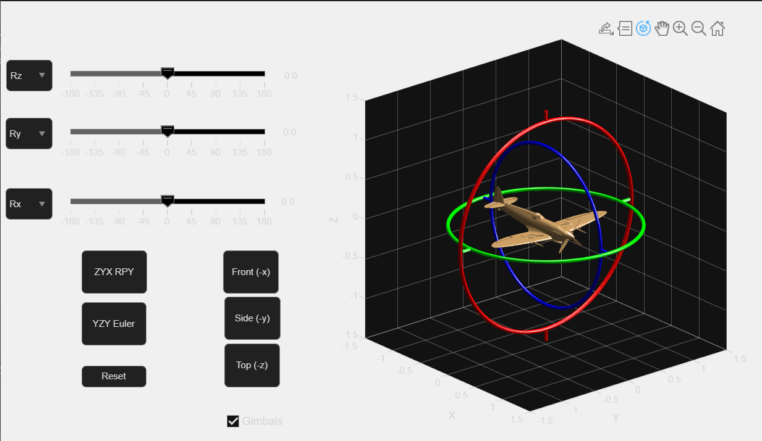
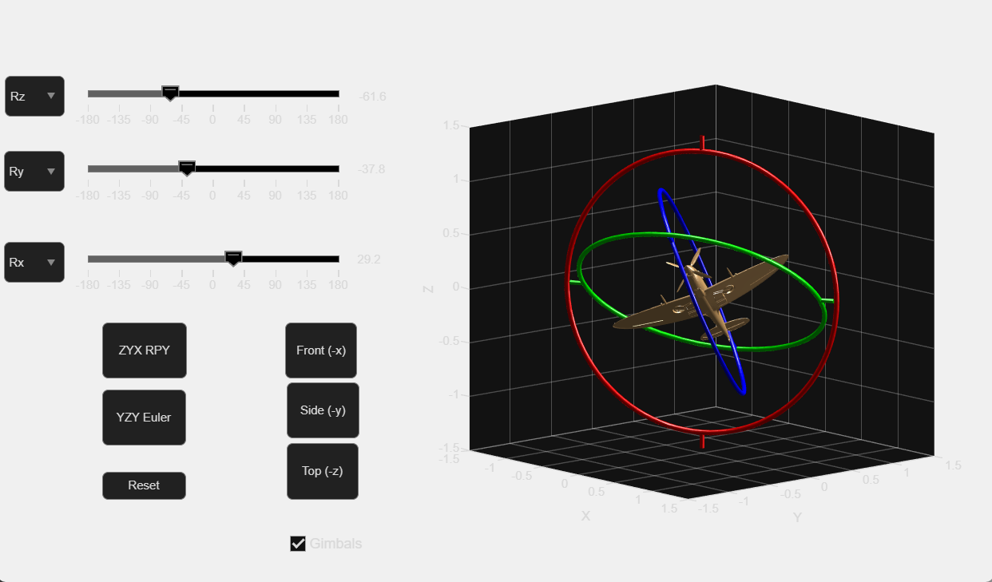

%% Robotics, Vision & Control 3e: for MATLAB
%% Chapter 2: Representing position & orientation
% 2.3.1.4 Two-Vector Representation

a = [0 0 -1];
o = [1 1 0];
R = oa2rotm(o,a)

Output:
>> peter_corkes_chapter2_code
R =
-0.7071 0.7071 0
0.7071 0.7071 0
0 0 -1.0000

>>
%% Robotics, Vision & Control 3e: for MATLAB
%% Chapter 2: Representing position & orientation
% 2.3.1.5 Rotation about an Arbitrary Vector

R = eul2rotm([0.1 0.2 0.3]);
rotm2axang(R)
[x,e] = eig(R)
theta = angle(e(2,2))
R = axang2rotm([1 0 0 0.3])

Output:
>> peter_corkes_chapter2_code
ans =
0.7900 0.5834 0.1886 0.3655
x =
-0.7900 + 0.0000i 0.1073 + 0.4200i 0.1073 - 0.4200i
-0.5834 + 0.0000i 0.0792 - 0.5688i 0.0792 + 0.5688i
-0.1886 + 0.0000i -0.6944 + 0.0000i -0.6944 + 0.0000i
e =
1.0000 + 0.0000i 0.0000 + 0.0000i 0.0000 + 0.0000i
0.0000 + 0.0000i 0.9339 + 0.3574i 0.0000 + 0.0000i
0.0000 + 0.0000i 0.0000 + 0.0000i 0.9339 - 0.3574i
theta =
0.3655
R =
1.0000 0 0
0 0.9553 -0.2955
0 0.2955 0.9553

>>
%% Robotics, Vision & Control 3e: for MATLAB
%% Chapter 2: Representing position & orientation
% 2.3.1.6 Matrix Exponential for Rotation

R = rotmx(0.3)
L = logm(R)
S = skew2vec(L)
expm(L)
expm(vec2skew(S))
R = rotmx(0.3);
R = expm(0.3*vec2skew([1 0 0]));
X = vec2skew([1 2 3])
skew2vec(X)

output:
>> peter_corkes_chapter2_code
R =
1.0000 0 0
0 0.9553 -0.2955
0 0.2955 0.9553
L =
0 0 0
0 0 -0.3000
0 0.3000 0
S =
0.3000 0 0
ans =
1.0000 0 0
0 0.9553 -0.2955
0 0.2955 0.9553
ans =
1.0000 0 0
0 0.9553 -0.2955
0 0.2955 0.9553
X =
0 -3 2
3 0 -1
-2 1 0
ans =
1 2 3

>>
%% Robotics, Vision & Control 3e: for MATLAB
%% Chapter 2: Representing position & orientation
% 2.3.1.7 Unit Quaternions

q = quaternion(rotmx(0.3),"rotmat","point")
q = q*q;
q.conj
q*q.conj()
q.rotmat("point")
q.compact()
q.rotatepoint([0 1 0])

output:
>> peter_corkes_chapter2_code
q =
quaternion
0.98877 + 0.14944i + 0j + 0k
ans =
quaternion
0.95534 - 0.29552i + 0j + 0k
ans =
quaternion
1 + 0i + 0j + 0k
ans =
1.0000 0 0
0 0.8253 -0.5646
0 0.5646 0.8253
ans =
0.9553 0.2955 0 0
ans =
0 0.8253 0.5646

>>
%% Robotics, Vision & Control 3e: for MATLAB
%% Chapter 2: Representing position & orientation
% 2.3.2 Pose in Three Dimensions
% 2.3.2.1 Homogeneous Transformation Matrix

T = trvec2tform([2 0 0])*tformrx(pi/2)*trvec2tform([0 1 0])
clf; plottform(T);
tform2rotm(T)
tform2trvec(T)

output:
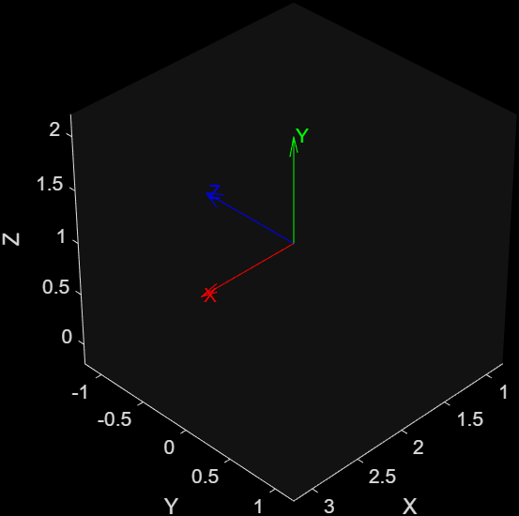
>> peter_corkes_chapter2_code
T =
1 0 0 2
0 0 -1 0
0 1 0 1
0 0 0 1
ans =
1 0 0
0 0 -1
0 1 0
ans =
2 0 1

>>
%% Robotics, Vision & Control 3e: for MATLAB
%% Chapter 2: Representing position & orientation
% 2.3.2 Pose in Three Dimensions
% 2.3.2.2 Matrix Exponential for Pose

T = trvec2tform([2 3 4])*tformrx(0.3)
L = logm(T)
S = skewa2vec(L)
expm(vec2skewa(S))
X = vec2skewa([1 2 3 4 5 6])
skewa2vec(X)

output:
>> peter_corkes_chapter2_code
T =
1.0000 0 0 2.0000
0 0.9553 -0.2955 3.0000
0 0.2955 0.9553 4.0000
0 0 0 1.0000
L =
0 0 0 2.0000
0 0 -0.3000 3.5775
0 0.3000 0 3.5200
0 0 0 0
S =
0.3000 0 0 2.0000 3.5775 3.5200
ans =
1.0000 0 0 2.0000
0 0.9553 -0.2955 3.0000
0 0.2955 0.9553 4.0000
0 0 0 1.0000
X =
0 -3 2 4
3 0 -1 5
-2 1 0 6
0 0 0 0
ans =
1 2 3 4 5 6

>>
%% Robotics, Vision & Control 3e: for MATLAB
%% Chapter 2: Representing position & orientation
% 2.3.2 Pose in Three Dimensions
% 2.3.3.3 3D Twists

S = Twist.UnitRevolute([1 0 0],[0 0 0])
expm(0.3*S.skewa());
S.tform(0.3)
S = Twist.UnitRevolute([0 0 1], [2 3 2], 0.5);
X = trvec2tform([3 4 -4]);
clf; hold on
view(3)
for theta = [0:0.3:15]
plottform(S.tform(theta)*X,style="rgb",labelstyle="none",LineWidth=2)
end
hold off
L = S.line();
L.plot("k:",LineWidth=2);
S = Twist.UnitPrismatic([0 1 0])
S.tform(2)
T = trvec2tform([1 2 3])*eul2tform([0.3 0.4 0.5]);
S = Twist(T)
S.w
S.pole
S.pitch
S.theta

Output:
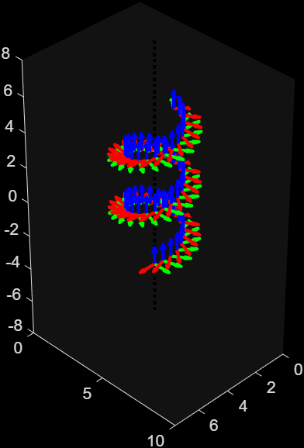
>> peter_corkes_chapter2_code
S =
S =
( 1 0 0; 0 0 0 )
ans =
1.0000 0 0 0
0 0.9553 -0.2955 0
0 0.2955 0.9553 0
0 0 0 1.0000
S =
S =
( 0 0 0; 0 1 0 )
ans =
1 0 0 0
0 1 0 2
0 0 1 0
0 0 0 1
S =
S =
( 0.42969 0.46143 0.19003; 0.53084 2.5512 2.7225 )
ans =
0.4297 0.4614 0.1900
ans =
1.1714 -1.6232 1.2927
ans =
1.9226
ans =
0.6585

>>
%% Robotics, Vision & Control 3e: for MATLAB
%% Chapter 2: Representing position & orientation
% 2.4 Advanced Topics
% 2.4.5 Distance Between Orientations

q1 = quaternion(rotmx(pi/2),"rotmat","point");
q2 = quaternion(rotmz(-pi/2),"rotmat","point");
q1.dist(q2)

output:
>> peter_corkes_chapter2_code
ans =
2.0944

>>
%% Robotics, Vision & Control 3e: for MATLAB
%% Chapter 2: Representing position & orientation
% 2.4 Advanced Topics
% 2.4.6 Normalization

R = eye(3);
det(R)-1
for i = 1:100
R = R*eul2rotm([0.2 0.3 0.4]);
end
det(R) - 1
R = tformnorm(R);
det(R)-1
q = q.normalize();

output:
>> peter_corkes_chapter2_code
ans =
0
ans =
3.7748e-15
ans =
0

>>
%% Robotics, Vision & Control 3e: for MATLAB
%% Chapter 2: Representing position & orientation
% 2.4 Advanced Topics
% 2.4.8 More About Twists

S = Twist.UnitRevolute([1 0 0],[0 0 0])
S.compact()
S.v
S.w
S.skewa()
expm(0.3*S.skewa)
S.tform(0.3)
S2 = S*S
S2.printline(mode="axang", unit="rad")
line = S.line()
clf; axis([-2 2 -2 2 -2 2]); view(3); xlabel("x"); ylabel("y"); zlabel("z"); grid on
line.plot("k:",LineWidth=2);
T = trvec2tform([1 2 3])*eul2tform([0.3 0.4 0.5]);
S = Twist(T)
S/S.theta
S.unit();
S.tform(0)
S.tform(1)
S.tform(0.5)

Output:
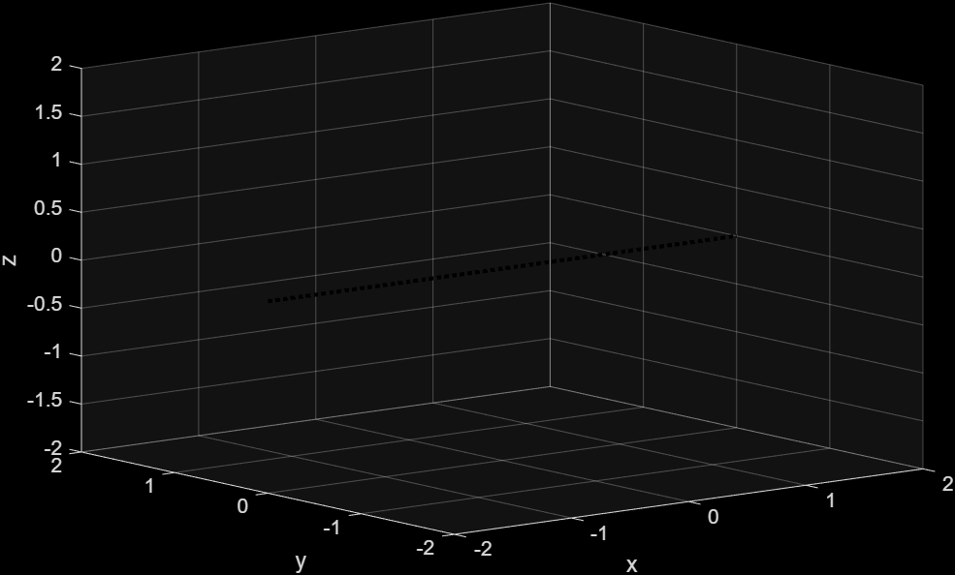
>> peter_corkes_chapter2_code
S =
S =
( 1 0 0; 0 0 0 )
ans =
1 0 0 0 0 0
ans =
0 0 0
ans =
1 0 0
ans =
0 0 0 0
0 0 -1 0
0 1 0 0
0 0 0 0
ans =
1.0000 0 0 0
0 0.9553 -0.2955 0
0 0.2955 0.9553 0
0 0 0 1.0000
ans =
1.0000 0 0 0
0 0.9553 -0.2955 0
0 0.2955 0.9553 0
0 0 0 1.0000
S2 =
S2 =
( 2 0 0; 0 0 0 )
t = (0, 0, 0), R = (2rad | 1, 0, 0)
line =
{ -0 -0 -0; 1 0 0}
S =
S =
( 0.42969 0.46143 0.19003; 0.53084 2.5512 2.7225 )
ans =
ans =
( 0.6525 0.70069 0.28857; 0.8061 3.8741 4.1342
ans =
1 0 0 0
0 1 0 0
0 0 1 0
0 0 0 1
ans =
0.8799 -0.0810 0.4682 1.0000
0.2722 0.8936 -0.3570 2.0000
-0.3894 0.4416 0.8083 3.0000
0 0 0 1.0000
ans =
0.9692 -0.0687 0.2367 0.3733
0.1179 0.9727 -0.2001 1.1386
-0.2165 0.2218 0.9508 1.4498
0 0 0 1.0000

>>
%% Robotics, Vision & Control 3e: for MATLAB
%% Chapter 2: Representing position & orientation
% 2.5 MATLAB Classes for Pose and Rotation

T = trvec2tform([1 2 3])*tformrx(0.3) % create SE(3) matrix as a MATLAB matrix
whos T
T = se3(rotmx(0.3),[1 2 3]) % create SE(3) matrix as an se3 object
whos T
T.tform()
whos ans
T.rotm()
T.trvec()
clf; plotTransforms(T,FrameLabel="A",FrameColor="b");
clf; plottform(T);
printtform(T);
P = [4 5 6]; % 3D point as a row vector
T.transform(P)
T.transform(P',IsCol=true)
T = rigidtform3d(rotmx(0.3),[1 2 3]) % create SE(3) matrix as a rigidtform3d object
whos T
T.A
T.R
T.Translation
T.transformPointsForward(P)
q = quaternion(rotmx(0.3),"rotmat","point")
conj(q)
q.conj()
q.conj

output:
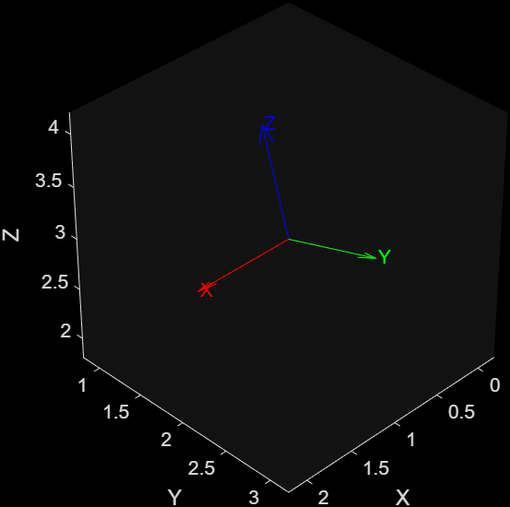
>> peter_corkes_chapter2_code
T =
1.0000 0 0 1.0000
0 0.9553 -0.2955 2.0000
0 0.2955 0.9553 3.0000
0 0 0 1.0000
Name Size Bytes Class Attributes
T 4x4 128 double
T =
se3
1.0000 0 0 1.0000
0 0.9553 -0.2955 2.0000
0 0.2955 0.9553 3.0000
0 0 0 1.0000
Name Size Bytes Class Attributes
T 1x1 136 se3
ans =
1.0000 0 0 1.0000
0 0.9553 -0.2955 2.0000
0 0.2955 0.9553 3.0000
0 0 0 1.0000
Name Size Bytes Class Attributes
ans 4x4 128 double
ans =
1.0000 0 0
0 0.9553 -0.2955
0 0.2955 0.9553
ans =
1 2 3
t = (1, 2, 3), RPY/zyx = (0, 0, 0.3) rad
ans =
5.0000 5.0036 10.2096
ans =
5.0000
5.0036
10.2096
T =
rigidtform3d with properties:
Dimensionality: 3
Translation: [1 2 3]
R: [3×3 double]
A: [1.0000 0 0 1.0000
0 0.9553 -0.2955 2.0000
0 0.2955 0.9553 3.0000
0 0 0 1.0000]
Name Size Bytes Class Attributes
T 1x1 97 rigidtform3d
ans =
1.0000 0 0 1.0000
0 0.9553 -0.2955 2.0000
0 0.2955 0.9553 3.0000
0 0 0 1.0000
ans =
1.0000 0 0
0 0.9553 -0.2955
0 0.2955 0.9553
ans =
1 2 3
ans =
5.0000 5.0036 10.2096
q =
quaternion
0.98877 + 0.14944i + 0j + 0k
ans =
quaternion
0.98877 - 0.14944i + 0j + 0k
ans =
quaternion
0.98877 - 0.14944i + 0j + 0k
ans =
quaternion
0.98877 - 0.14944i + 0j + 0k
>>

